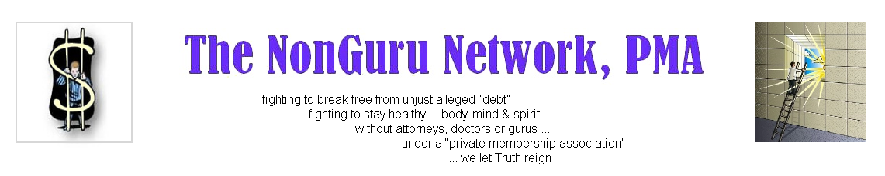

FROM: **The NonGuru Network, PMA** TRUSTEE BOARD

DATE: MAY 28, 2011

RE: UPDATE REGARDING START OF NETWORK

C:\Documents and Settings\user\Local Settings\Temporary Internet Files\Content.IE5\849DR6XD\MC900104878[1].wmf

Hello my friends,

Again, for those who have expressed their desire to become a member, we thank you for your interest in **The NonGuru Network, PMA**. This is an update to let you know that we are still pressing forward in our quest to bring you a platform that focuses on you and your concerns, ***without gurus***, regarding the law and alternative health in a safe and private environment, without the interference of government.

C:\Documents and Settings\user\Local Settings\Temporary Internet Files\Content.IE5\J4CKBK25\MC900228833[1].wmf C:\Documents and Settings\user\Local Settings\Temporary Internet Files\Content.IE5\J4CKBK25\MC900228833[1].wmf C:\Documents and Settings\user\Local Settings\Temporary Internet Files\Content.IE5\J4CKBK25\MC900228833[1].wmf

Based on the questions we have been receiving lately, please be advised that The NonGuru Network, PMA has not started accepting members yet. You will be notified when we will start accepting members, which I (P.N.) pray is soon.

C:\Documents and Settings\user\Local Settings\Temporary Internet Files\Content.IE5\L81N4ML7\MC900358961[1].wmf

The sacrificial work of helping others in this foreclosure mess appears to be a never ending task and it has greatly slowed our progress in launching The NonGuru Network, PMA, but we are pressing forward with zeal. We thank you for your patience.



C:\Documents and Settings\user\Local Settings\Temporary Internet Files\Content.IE5\8WIP4387\MC900287184[1].wmfI (P.N.) am pleased to report that we have purchased software materials to be able to create teaching modules via video, software to help with writing and communication skills, which I have found to be sorely needed and is not being taught by most of the so-called gurus in the *sui juris* arena (actually, I have not seen any).

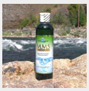We have also purchased supplies (not all) to create MMS (more on that later). This is exciting! The NonGuru Network, PMA will be selling this excellent, inexpensive healing product to its members (and only to members - it will not be sold to the public) at a rock-bottom (below market) prices. Our purpose is to help, heal and to inspire one another - not to seek ungodly profit off of other people's dilemmas and misery.

C:\Documents and Settings\user\Local Settings\Temporary Internet Files\Content.IE5\8WIP4387\MC900105218[1].wmf

Those of you who have donated to the start-up cause (Lynda, Steve, Alison & Dan, Rick), we, again, give our sincere thanks. We have raised $700 so far. Of course we need more; however, every penny will help.

Please be advised that those who donate to the start-up, said donation credit will be applied towards your membership fee and webinars. Hence, your donation will be serving two or three purposes at one time. An effective use of your credit resources.

C:\Documents and Settings\user\Local Settings\Temporary Internet Files\Content.IE5\J4CKBK25\MC900104734[1].wmf

For those who have not put their name on the prelaunch list, you can do so by sending an email to [info@thenongurunetwork.com](mailto:info@thenongurunetwork.com), after reading this document: <http://www.myprivateaudio.com/thenongurunetwork_-_PRELAUNCH2_.pdf>

Again, for those who have communicated with us, we thank you for your patience and your appreciation of what we have done and are doing. Your comments of appreciation are well received and they are fuel to keep us pressing forward in the times when we are overwhelmed with the tasks at hand. We all have sacrificed a great deal to help others, but it's worth it. Be well my friend, keep the faith, keep learning and keep fighting.

Your friends in the battle with you,

Private Nobody, Primary Trustee

B.A. Nonimus, Trustee

MAAT , Trustee

Victoria Warrior, Trustee

Learn how to beat the debt collectors and easily take their money for violating the law. <http://debtcollectorslose.com> A ***proven system*** makes you money while you are able to keep your home, fight off debt collectors, credit card companies, etc., and get you paid! <http://debtcollectorslose.com>  
  
Anyone who is inspired to help Private Nobody financially for the website and other start-up expenses (so far, most of it has been coming out of his pocket), please send a **PayPal donation** to [info@thenongurunetwork.com](mailto:info@thenongurunetwork.com). (*Note: If you have a PayPal account, use the "Personal" and "Other" tabs so that the full amount of the donation is received*.) Your donation, as aforementioned, will be applied towards your membership fee into the **The NonGuru Network, PMA** and any webinar events. Private Nobody cannot do this project by himself. Every little bits help. Please help. Thank you.